

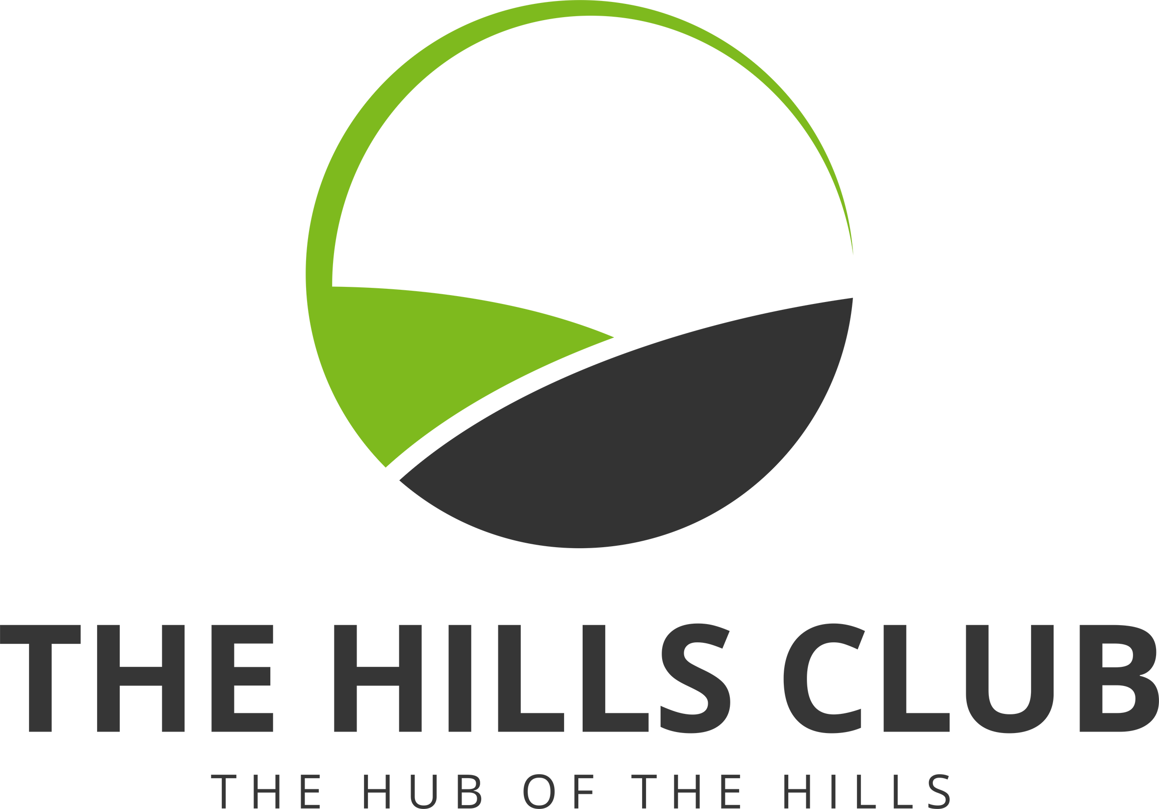

Directors Reports

Year ending 31st May 2025



Board of Directors

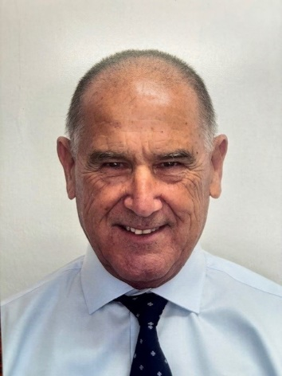

Chairperson

# Ken Carroll

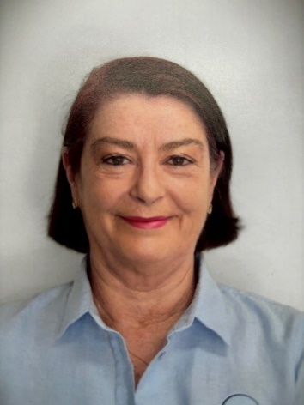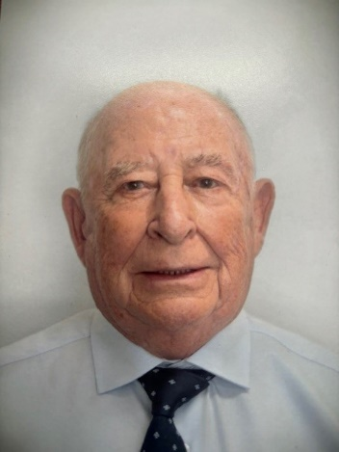

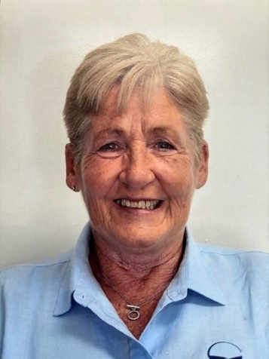

Vice – Chairperson

Karen McCann

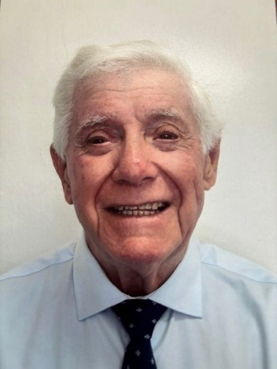

Director

David Smith

Director

Phil Axiak

Director

Dennis Halford

Treasurer

# Elizabeth Leahy

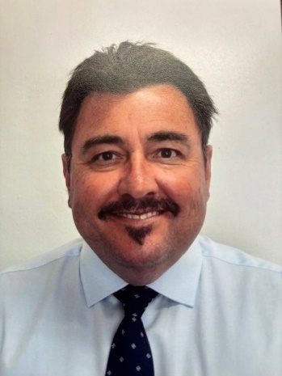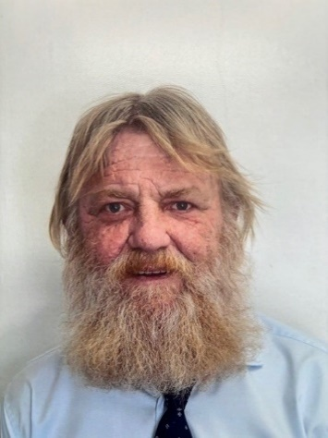

Director

Glenn Hall





## Chairperson’s Report

Dear Members,

It is with great pleasure that I present the Chairperson’s Annual Report for the Hills Bowling Club for 2024/25. This year has been a very good one for our members, and I am delighted to share the progress and achievements of our club over the past twelve months.

**1. Club Overview**

In a very challenging regulatory environment, our club continues to thrive as a vibrant community social hub, also growing our members interest and involvement with bowls. We welcomed many new members this year, bringing our total membership to around 7,000. One of our goals for 25/26 is to encourage those members who are infrequent visitors to our club to come back and experience the great food and beverage offering.

**2. Financial Performance**

I am pleased to report that the club’s financial position remains strong in a very challenging environment. Our Treasurer will provide more details.

**3. Club Redevelopment**

You will recall that members voted in 2019 to proceed with plans for the redevelopment of the Club. The Club signed a 5-year Agreement with Arden Clubs in May 2020 which included a commitment from them to obtain a Development Approval by May 2025. This was not achieved.

During these past 5 years, there have been considerable changes to the Local and State Government planning systems which may have affected the project outcomes. The Club’s Board and Management have worked diligently with Arden and The Hills Council to obtain the necessary approvals.

The Board made the decision to terminate the Agreement with Arden on 28th May, 2025.

The Board will give serious consideration over the next 12 months as to what is the best outcome for our Club into the future, which of course may be a redevelopment.

**4. Bowls**

Our bowls calendar was once again very full for both the men and women, and of course mixed events. We have a high participation rate at club level and region events.

Social bowling is a very important part of our club which gives many non-competitive bowlers the opportunity to match their abilities with some of our top bowlers. It is also important for the health and well-being of all bowlers – both young and old.

Thanks to our hard-working bowls committees and to our Bowls Secretary Andrew, who is always calm and collected whilst managing complex scheduling and unpredictable weather interventions.

**5. Membership and Community Engagement**

This year, we have seen an increase in club functions where we have received overwhelmingly positive feedback from members and visitors, and we are committed to continuing these efforts to enhance member satisfaction and community involvement.

**7. Acknowledgements**

I would like to extend my heartfelt thanks to our General Manager Melissa and her dedicated staff, as well as members of the Board of Directors and volunteers whose hard work and commitment have been instrumental in our success this year.

**8. Looking Ahead**

As we move into the next year, our focus will be on ensuring the club continues to meet the expectations of our members and guest. We are seeing more and more complex legal issues around gaming and other areas, with our General Manager continuously monitoring all of these complexities and keeping the Board informed.

I am confident that with the continued support of our members and the efforts of our management and staff, committees and the Board, we will continue to make the Hills Bowling Club a place where everyone feels welcome and valued.

Thank you all for your continued support and dedication to the club. Here’s to another successful year ahead!

Ken Carroll  
Chairperson, Hills Bowling Club

